

An Undergraduate Internship

Report On

Laravel E-Commerce Website

Submitted By

Name: Abhijit Chowdhury

ID: 1610113

Autumn,2020

Supervisor:

Mohammad Noor Nabi

Senior Lecturer

Department of Computer Science and Engineering

Independent University, Bangladesh

Dissertation submitted in partial fulfillment for the degree of Bachelor of Science in Computer Science and Engineering

Department of Computer Science and Engineering

Independent University, Bangladesh

**Attestation**

I hereby declare that the report namely “Laravel E-Commerce Website” is based on my own work, based on my personal work by me during my Internship period and that I have acknowledged all sources and materials used in this report.

I also declare that this report is my original work and does not breach any existing copyright. This particular report has not been previously submitted for assessment in any other unit.

Following the internationally accepted academic guideline of using other’s written work or software is properly cited if used in any part of this work.

Signature: …………………

Date: ………………………

Name: ABHIJIT CHOWDHURY

**Acknowledgement**

Firstly, I would like to express my deepest sense of gratitude to Almighty for giving the opportunity and ability to work hard. Then I would like to thank Independent University, Bangladesh for offering Internship program.

Secondly, I would like to thank my academic supervisor Md. Noor Nabi Sir, Senior Lecturer, Department of Computer Science and Engineering, Independent University, Bangladesh, for providing me constant supervision for the completion of this report.

It has been a great privilege to work with Cursor as an Intern. The Internship opportunity I had with Cursor was a great chance for learning and professionally developed myself into it. Therefore, I am grateful for having a chance to meet so many wonderful people and professionals who led me throughout this Internship period.

I also perceive this opportunity as a big milestone to build up my career. I will try to improve myself more and more to attain desired career objectives. Finally, I would like to thank my family members for their great sacrifices, support, encouragement and inspiration.

Letter of Transmittal

January10, 2021

Md. Noor Nabi

Senior Lecturer

Department of Computer Science and Engineering

Independent University, Bangladesh

Subject: Submission of Internship Report.

Dear Sir,

It is a great pleasure to submit the final Internship Report named as “Laravel E-Commerce Website” at Cursor for my CSE 499: Internship Program. Hopefully, you will discover my well-researched, informative approach as a hallmark of hard work. The entire report is based on Web Development using Laravel and React that I have designed and built during the whole Internship time. Consequently, I am submitting my report on your very concern. I also want to thank you for your support and patience with me and I would be glad if you accept this report and provide your precious judgement. In case of any further clarification to my report, I would welcome the opportunity to consult with you to explore how my findings could best meet your needs.

Sincerely,

ABHIJIT CHOWDHURY

ID: 1610113

**Evaluation Committee**

Signature: …………………………

Name: …………………………….

Supervisor: ……………………….

Signature: …………………………

Name: …………………………….

Internal Examiner: ……………………….

Signature: …………………………

Name: …………………………….

External Examiner: ……………………….

Signature: …………………………

Name: …………………………….

Convener: ……………………….

**Abstract**

E-Commerce refers to the buying and selling of goods or services using the internet, and the transfer of money and data to execute the transactions. In this report, I have written about my internship experience at Cursor as an intern which provided me the opportunity to work with a real- life Software Application. It helped me to become more familiar from development to production life cycle.

This project named EShop mainly deals with developing an e-commerce website for online product sale. It provides the user with a catalog of different product available for purchase from the store. In order to facilitate the online purchase, a shopping cart has been provided to the user. The selected items which will be collected will be presented in an orderly form during the checkout time. In order to complete the transaction, more information will be needed. Usually, the customer will be asked to fill the billing address, payment gateway. The system is implemented using backend database, Model, View and Controller (MVC) architecture. The scaffolding of react-laravel is customized here to improve the performance and scalability of the system. These include client, vendor and admin architecture using scripting languages such as PHP, MySQL, Bootstrap, HTML 5, React Js.

This report will discuss each of the techniques and relations of the modern e-commerce website from objectives, requirement analysis, methodology, management, testing to implementation of the e-commerce system.

# Table of Contents

#### Introduction 12

* 1. Background…………………………………………………………….12
  2. Overview.……….….……………………………………………….… 13
  3. Objective 15
  4. Scope of the project 15

#### Literature Review 17

* 1. Introduction 17
  2. Relationship with Undergraduate Studies 18
  3. Related Works 18

#### Project Management and Financing 19

* 1. Work Breakdown Structure (WBS) 19
  2. Process Activity Wise Time Distribution 20
  3. Gantt Chart 22
  4. Estimated Costing 23

#### Methodology 24

* 1. Implementation 24
  2. Workflow Methodology 24

**5 Body of The Project 25**

5.1 **System Analysis**……………………………………………………...25

5.1.1 Six Element Analysis ……………………………………………….25

5.1.2 Entity Relationship Diagram………………………………………. 26

5.1.3 Use Case Diagram…………………………………………………. 27

5.1.4 Activity Diagram…………………………………………………… 28

5.1.5 Feasibility Analysis…………………………………………………. 31

5.1.6 Problem, Solution and Constraint Analysis……………………….32

5.2 **System Design**…………………………………………………………….33

5.2.1 Rich Picture………………………………………………………………...33

5.2.2 UML Diagram………………………………………………………………34

5.2.3 Functional and Non-Functional Requirements…………………………35

5.3 **Project Features**…………………………………………………………38

5.3.1 Home Page……………………………………………………………. 38

5.3.2 About Us………………………………………………………………. 39

5.3.3 Products………………………………………………………………… 39

5.3.4 Brands…………………………………………………………………… 40

5.3.5 News Feed……………………………………………………………… 40

5.3.6 Contact Us……………………………………………………………… 41

5.3.7 Add To Cart………………………………………………………………41

5.3.8 Register Form……………………………………………………………42

5.3.9 User Login Form…………………………………………………………42

5.3.10 Admin Dashboard……………………………………………………….43

5.3.11 Vendor Dashboard………………………………………………………43

**6** **Result and Test Analysis**   **44**

6.1 Test Case 44

* 1. Results 47

**7 Project as Engineering Problem Analysis** **48**

* 1. Sustainability of the Project 48

7.2 Social and Environmental Effects and Analysis…………………….49

7.3 Addressing Ethics and Ethical Issues 50

1. **Future Work and Conclusion 51**
   1. Future Works 51

8.2 Conclusion 52

**References 53**

**List of Figures**

* 1. Work Breakdown Structure 19
  2. Time Distribution Pie Chart 21
  3. Gantt Chart 22
  4. Entity Relationship Diagram 26
  5. Use Case Diagram 27
  6. Activity Diagram for User 28
  7. Activity Diagram for Admin 29
  8. Activity Diagram for Vendor 30
  9. Rich picture of E-Commerce 33
  10. UML Diagram……………………………………………………………………………………..34
  11. Home Page 38
  12. About Page 39
  13. Products Page 39
  14. Brands Page 40
  15. News Feed Page 40
  16. Contact Us Page 41
  17. Add To Cart Page 41
  18. Register Form Page 42
  19. User Login Page 42
  20. Admin Dashboard Page 43
  21. Vendor Dashboard Page 43

# List of Tables

* 1. Activity Wise Time Distribution Table 20
  2. Estimated Costing 23
  3. Table of Six Element Analysis 25
  4. Table of Problem, Analysis, Solution and Constraints 32
  5. Consistency Table. 34
  6. Registration Table. 35
  7. Login Table. 35
  8. Create Account Table 35
  9. Modify Account Table 35
  10. Request Order Table 35
  11. Approve Pending Request Table 36

6.1 Test Cases for Admin Login 43

* 1. Test Cases for User Registration 44

6.3 Test Cases for User Login 44

6.4 Test Cases for Edit/Delete User Profile 4

# Chapter 1 Introduction

E-commerce, also known as internet commerce is fast gaining ground as an acceptance and used business paradigm. More and more software sectors are building websites providing functionality for performing commercial transactions over the web. The process of shopping on the web is on a increased basis day by day.

In this report, I am representing my work experience as an intern at Cursor. In order to develop the e-commerce store where the buyer or visitor can see and select the available products and can buy it from anywhere through internet. The selected item may be collected in a shopping cart and at checkout time, the customer can finalize the order and more information will be required to complete the purchase. The customer will be asked for billing information and payment gateway process in order to complete the transaction.

**1.1 Background**

With the regularly expanding utilization of the web and its prominence among every single segment fragment, electronic trade is by all methods the best approach for basically all organizations. It is practically inconceivable for an organization to contend in the present serious business world on the off chance that it does not have a solid online presence, which is the pith of web-based business. A wide scope of little and huge software sectors had utilized web based business to support deals by posting their administrations and items on the web, where buyers can check them and can add them in a cart, quite easily without any sort of hassle.

Cursor usually take projects from various clients and make various sorts of software in order to fulfill the client requirements. Official work can be done through this. As I am doing my internship at Cursor they told me to work on this project. As ecommerce is growing rapidly they got a project of ecommerce in which I had worked with the developer team in order to build the e-commerce successfully.

* 1. **Overview of Cursor**

Cursor, a fast-growing software-based tech company working on various projects with clients which helps people to experience the greater benefits on the internet. Cursor also provide tech support as well as other technical business solutions. They provide Website Development, E-commerce Solution, Mobile Application Development (Android, iOS), CCTV technical support, Graphics Designing, ERP, Hotel and Restaurant Management to their clients.

* + 1. **Company Profile of Cursor**



**CLICK YOUR DREAM**

Though Cursor is quite a big company it has various sectors for different sorts of work. As a company it has some basic departments such as HR, Business Development, Engineering, Security, Marketing department, Production department. Cursor also have a group of experts from different fields to make reliable products to meet the customer demand and requirements. Now to cope up with this rapid change, they are developing their sector through IT solutions to ensure the best possible outcome.

#### 1.2.2 Mission and Vision of Cursor

i) **Mission**

Contribute to help the whole world and try best to fulfill high-quality software products in every part of the IT sector and also research about new technology.

**ii) Vision**

The company always try to give opportunities by offering mentorship and internship programs hosting regular workshops and sessions for skill knowledge transfer. Figure out the needs of the IT market and research in those and try to provide the best solution to fulfill the needs.

**1.3 Objective**

Project objectives always needs to be stated clearly as these will impact every decision in the project lifecycle. Project objectives must be measurable and contain key performance indicators that will be used to assess a project's success. The main objective of the e-commerce is to reduce management costs, develop business relations, providing customer unique experience, time efficiency, increasing sales and user friendly interface.

* 1. **Scope of the project**

After developing the e-commerce the features available for user, admin and vendor are:

**For Users**:

* Home
* Login
* About Us
* Products
* Brands
* News Feed
* Contact Us

**For Admin**:

* Login
* Dashboard
* Add Products
* Edit Product
* All Products
* Vendor Management
* Client Management
* Orders
* Types
* Category
* Brands

**For Vendor:**

* Dashboard
* Brands
* Orders
* Add Products
* All Products

# Chapter 2

**Literature Review**

## 

**2.1 Introduction**

E-commerce deals with all kind of product details. As we all know, the internet and e-commerce are expanding at increasing rate. It can make a remarkable benefit to anyone if an ideal business purpose can be made. E-commerce website increases the overall productivity of the team. It points to form the ultimate, exact representation of the knowledge and research-based hypothesis accessible information.

**2.2 Relation with Undergraduate Studies**

In my Undergraduate studies, most of the courses like Database Management, Web Application, System Analysis and Design, Software Engineering courses helped me a lot to document and implementing my task in the Internship program. In my e-commerce project, I have implemented what I have learned in these respective courses. The programming languages, the management system of the database helped me a lot to develop this project.

**2.3 Related Works**

E-commerce stage have gradually crawled into our day by day lives. These days, online tech giants like Amazon, Alibaba, Ebay, BdJobs etc are well-known for their incredible worldwide services and helpful acquiring choices.

Nowadays e-commerce is not a website it’s a way to grow business faster. There are many software and website like this. Globally many software companies offer an e-commerce of business. Their purpose oriented design, responsive layout and special features like selecting products, about, services, pricing, gallery items, discounts are making the attraction towards people in order to buy their desirable services and products.

# Chapter 3

**Project Management and Financing**

**3.1 Work Breakdown Structure (WBS)**

A Work Breakdown Structure (WBS) could be a various leveled structure of things that the project will make or results that will convey. We utilize the top-down approach to appear Work Breakdown Structure (WBS) of our e-commerce project. We made a WBS for this extend. This will be supportive for us to preserve work quality and simple to synchronize the complete project.

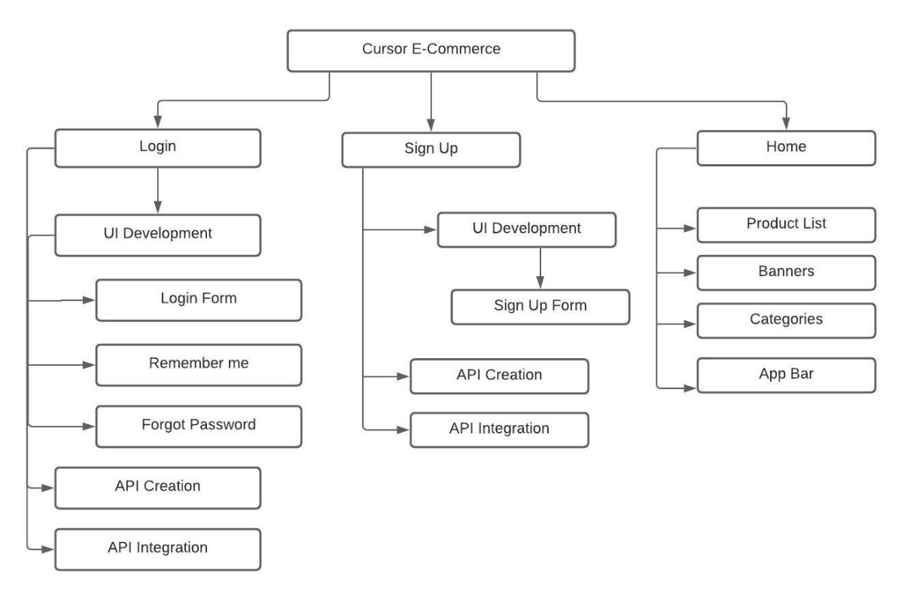

Figure 3.1: Work Breakdown Structure

**3.2 Process Activity Wise Time Distribution**

In Activity wise time distribution, here Work Breakdown Structure is collected where all the activities are included. We attempted the whole work in a time outline. Along working with a group extend, checking the time and working nearby with group individuals time planning. The entire work will divide and show the work flow of our e-commerce project. To preserve this workflow conveyance time is assessed is for the e-commerce project.

|  |  |  |  |
| --- | --- | --- | --- |
| **SL.** | **Task Management** | **Days** | **Durations** |
| 1 | Front End Developer | 18 | 22.5% |
| 2 | Back End Developer | 32 | 40% |
| 3 | Project Manager | 8 | 10% |
| 4 | Software Testing | 10 | 12.5% |
| 5 | Analysis and Result | 8 | 10% |
| 6 | Deployment | 4 | 5% |
|  | Total | 80 | 100% |

Table 3.1: Activity Wise Time Distribution Table

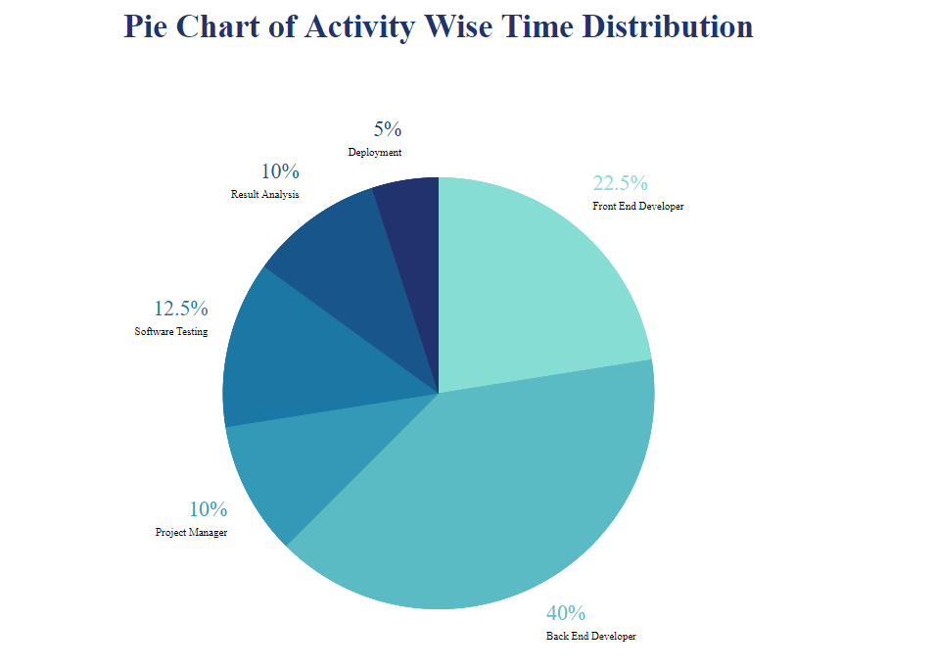

Figure 3.2: Pie Chart of Activity Wise Time Distribution

**3.3 Gantt Chart**

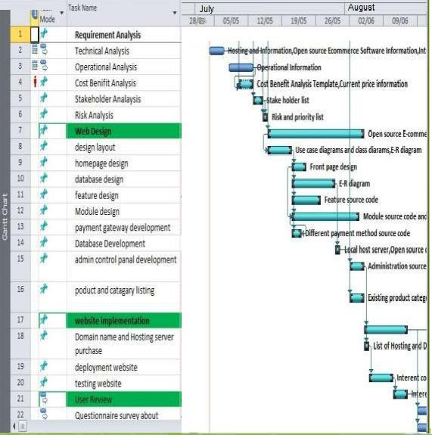

Figure 3.3: Gantt chart

**3.4 Estimated Costing**

The starting estimated costing will be around approximately 40,000 BDT. This is the calculative cost of the project. It can be expanded on the basis of change in the software and also on the demand and requirement of the user and development criteria.

|  |  |  |
| --- | --- | --- |
| **SL** | **Task Management** | **Pricing (BDT)** |
| 1 | Setup | 3000 |
| 2 | Front End Development | 10,000 |
| 3 | Back End Development | 15,000 |
| 4 | Testing | 4000 |
| 5 | Project Management | 7000 |
| 6 | Hosting | 2000 |
|  | Total | 41000 |

Table 3.2: Estimated Costing

# Chapter 4

**Methodology**

**4.1 Implementation**

Methodology is the detailed procedure of system used to identify, select, process, and analyze information about a subject. The website I have been assigned to work on is an E-Commerce where analyzing the system and user requirement is the key in building up the whole development phase. Here, I have used HTML5 to load images and design, CSS3 to include color and fonts, PHP for scripting language and JavaScript for dynamic web page interactive.

**4.2 Workflow Methodology**

Customers build up a sense of loyalty to those e-commerce websites that offer them a good user experience, and that transmit to confidence and reliability. All of these factors determine the impact of attracting customers. Customer will gain interest to buy products again and again if the searching of product is created in a easier way. The payment gateway needs to be simple and logical without any sort of fear. Our e-commerce development is user-friendly and can be easily attracted as the selection of product and payment process is created in a user-friendly approach.

# Chapter 5

**Body of The Project**

**5.1.1 Six Element Analysis**

|  |  |  |  |  |  |  |
| --- | --- | --- | --- | --- | --- | --- |
| **Process** | **Human** | **Non**  **Com- puting Hard- ware** | **Com- puting Hard- ware** | **Software** | **Database** | **Connec- tivity** |
| Registration | User | - | PC,  Laptop, Mobile | Browser | DBMS | Internet |
| Login | User,  Admin, Doctor | - | PC,  Laptop, Mobile | Browser | DBMS | Internet |
| Create  Hospital, Doctor | Admin | - | PC,  Laptop, Mobile | Browser | DBMS | Internet |
| View User,  Doctor, Hospital, Appointment | Admin | - | PC,  Laptop, Mobile | Browser | DBMS | Internet |
| Edit/Delete  User, Doctor, Hospital, Appointment | Admin | - | PC,  Laptop, Mobile | Browser | DBMS | Internet |
| Request Appointment | User | - | PC,  Laptop, Mobile | Browser | DBMS | Internet |
| Approve Appointment | Admin, Doctor | - | PC,  Laptop, Mobile | Browser | DBMS | Internet |

Table 5.1: Table of Six Element Analysis

**5.1.2 Entity Relationship Diagram**

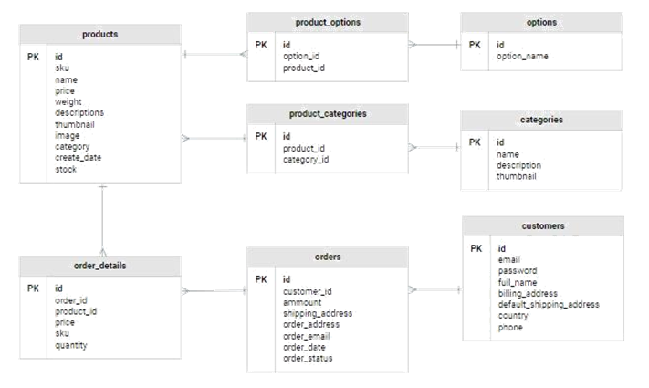

Figure 5.1: Entity Relationship Diagram

**5.1.3 Use Case Diagram**

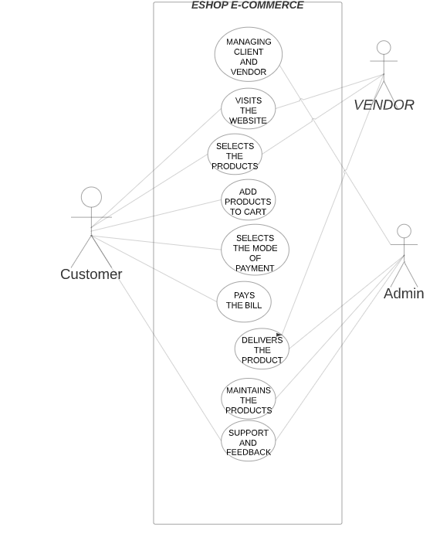

Figure 5.2: Use Case Diagram

**5.1.4 Activity Diagram:**

**Activity Diagram of User:**

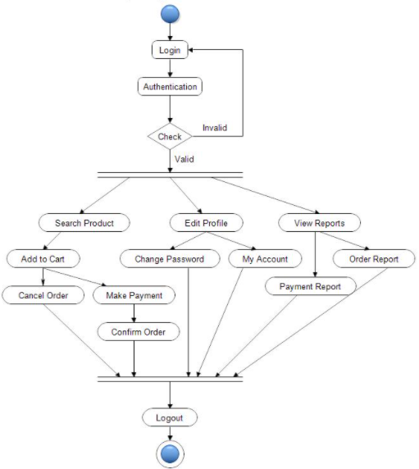

Figure 5.3: User Activity Diagram

**Activity Diagram of Admin:** 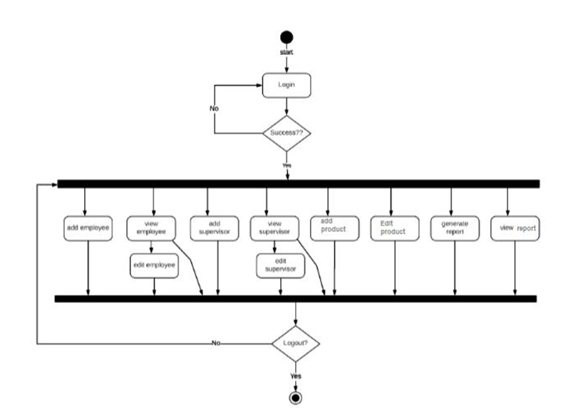

Figure 5.4: Admin Activity Diagram

**Activity Diagram of Vendor:**

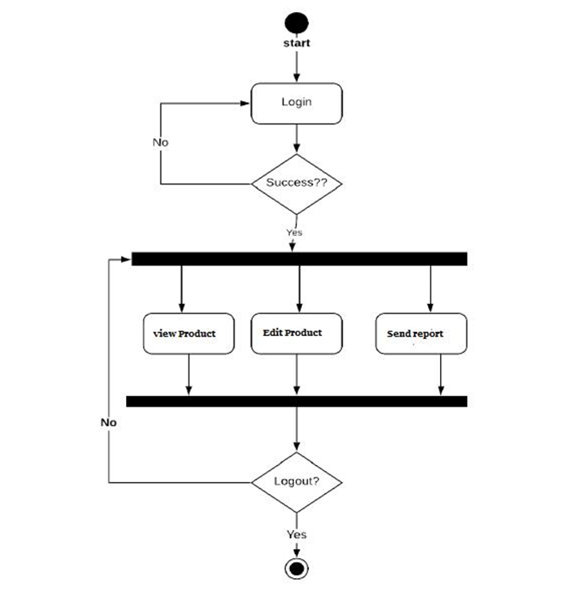

Figure 5.5: Vendor Activity Diagram

**5.1.5 Feasibility Analysis**

Our Laravel e-commerce has its workability, assembly of the user’s necessities, compelling utilize of assets and of course, cost-effectiveness. These are categorized as Technical, Operational, Financial, plan. Within the preparation of achievability consider, the fetched and benefits are assessed with more accurate precision. This too also defines the assets required to examine our e-commerce system. The result may be a possibility report submitted to the administration. This may be acknowledged with alterations or approval of the e-commerce.

* + - 1. **Financial Feasibility**: In terms of e-commerce, they process and system are quite costly. Those who are in startup conditions cannot afford the software. They have to maintain their calculations store data manually. Our software is relatively cheap and other features are there like Inventory.
      2. **Operational Feasibility**: We will be operating our e-commerce quite calculatively. Well our e-commerce system solves the problems, and takes advantage of the opportunities identified during scope definition and satisfies the requirements identified in the requirements analysis phase of system development.
      3. **Technical feasibility**: Our Company Cursor is one of the best company in terms of technical solutions. Our company always maintain experts to complete and maintain the project.

**5.1.6 Problem, Solution and Constraint Analysis**

|  |  |  |  |
| --- | --- | --- | --- |
| **Problem** | **Analysis** | **Solution** | **Constraints** |
| Data loss | Anytime data can  be lost for various reason like virus attack,  system hack and Unfortunately system crash) | Database system is much more secured as deleted and lost data can easily restore at any time. | Internet connectivity |
| Time Complexity | To excess to a  specific information it requires a lot of  time to find and compute, where time complexity takes place. | Database system is easily accessible and need less time. | Internet connectivity |
| Human error | User inputs invalid email or password | Auto fill-up form may apply to store in the database. | Error Rate  Prediction |
| Analysis the data | Some problem occurs  due to fetching manually different information | Database system can  collect all the data and it is very easy to analyses the data. | Internet connectivity |
| Steal Data | Anyone can steal  the data or data can be stolen. | Database system is  secured solution in terms of data lost problem. | Hacking User Data |

Table 5.2: Table of Problem, Analysis, Solution and Constraints

**5.2 System Design**

**5.2.1 Rich Picture:**

Our E-Commerce rich picture illustrates the most elements and connections that have to be considered in attempting to intercede in arrange to form a few advancements. This rich picture of our e-commerce demonstrate graphically the circumstance.

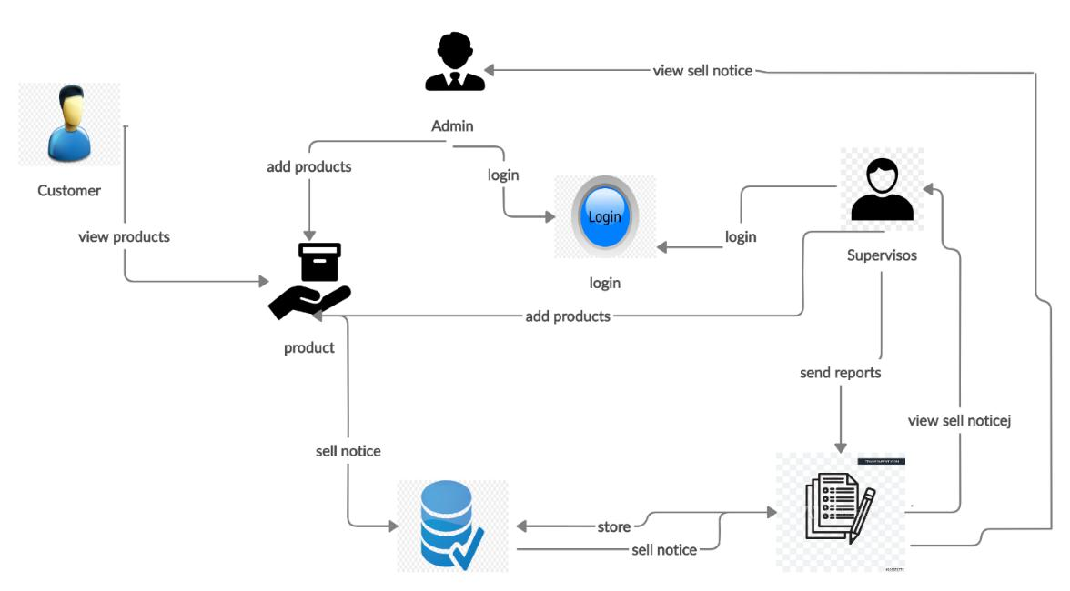

Figure 5.6: Rich Picture of E-Commerce

**5.2.1 UML Diagram:**

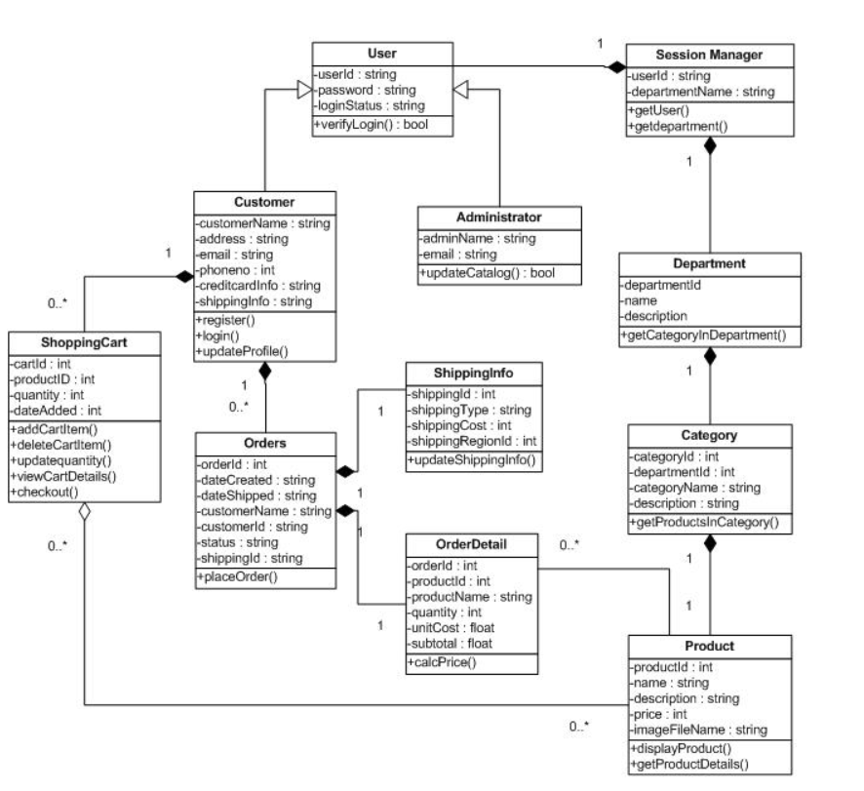

Figure 5.7: UML Diagram

**5.2.3 Functional and Non-Functional Requirements**

Requirements analysis is necessary as it involves all the tasks that are conducted to identify the needs of our e-commerce. Therefore, requirements analysis means analyzing, document, validate and manage software or system requirements. Great quality requirements are documented, actionable, measurable, testable, traceable, helps to identify opportunities, and are defined to facilitate system design as well.

**Functional Requirements:**

The functional requirement is that it essentially specifies something a system should do. The Functional Requirements are the operations and activities that a system must be able to perform.

|  |  |  |
| --- | --- | --- |
| **Function Name**: Consistent with all devices | | |
| **Input**: URL | **Process**:  Software must be created in a common Development Environment. | **Output**:  This software will be accessible in every device. |
| **Pre-Condition**: User must have a computer or smart device with net connection. | | |
| **Post Condition**: User can check all available products. | | |
| **Alternative Options**: N/A | | |

Table 5.3: Consistency Table

|  |  |  |
| --- | --- | --- |
| **Function Name**: Registration | | |
| **Input**:  Name, Email, Password | **Process**:  User must fill up the form to register in the system. | **Output**:  An account will be created of that username. |
| **Pre-Condition**: User must have a computer or smart device with net connection. | | |
| **Post Condition**: User can login and observe activities. | | |
| **Alternative Options**: If Email or Password are not valid then showing the alert | | |

Table 5.4: Registration Table

|  |  |  |
| --- | --- | --- |
| **Function Name**: Login | | |
| **Input**: Email and Password | **Process**:  Login User/Admin/Vendor interface. | **Output**:  View User/Admin/Doctor interface in the website. |
| **Pre-Condition**: Must have a computer or smart device with net connection. | | |
| **Post Condition**: User/Admin/Vendor can login and observe activities. | | |
| **Alternative Options**: If Email or Password are not valid then showing the alert | | |

Table 5.5: Login Table

|  |  |  |
| --- | --- | --- |
| **Function Name**: Create Account | | |
| **Input**:  ID and Password | **Process**:  Logged in and get to the form. | **Output**:  A new account will be created. |
| **Pre-Condition**: Must have a computer or smart device with net connection. | | |
| **Post Condition**: The data will be upgraded in the database. | | |
| **Alternative Options**: N/A | | |

Table 5.6: Create Account Table

|  |  |  |
| --- | --- | --- |
| **Function Name**: Modify Account | | |
| **Input**:  ID and Password | **Process**:  Logged in and get to the Edit/Delete button. | **Output**:  The information will be edited or removed. |
| **Pre-Condition**: Must have a computer or smart device with net connection. | | |
| **Post Condition**: The data will be upgraded in the database. | | |
| **Alternative Options**: N/A | | |

Table 5.7: Modify Account Table

|  |  |  |
| --- | --- | --- |
| **Function Name**: Order Request | | |
| **Input**:  User ID and Password | **Process**:  Fill up the required info and submit it. | **Output**:  An order invoice will be generated. |
| **Pre-Condition**: User must have a computer or smart device with net connection. | | |
| **Post Condition**: An Order is being processed. | | |
| **Alternative Options**: N/A | | |

Table 5.8: Request Order Table

|  |  |  |
| --- | --- | --- |
| **Function Name**: Approve Pending Request | | |
| **Input**:  Admin ID and Password | **Process**:  Can approve pending request. | **Output**: Request approved. |
| **Pre-Condition**: Admin must have a computer or smart device with net connection. | | |
| **Post Condition**: The pending request will be approved. | | |
| **Alternative Options**: N/A | | |

Table 5.9: Approve Pending Request

**Non-Functional Requirements:**

A non-functional requirement is a qualitative prerequisite for a project. A non-functional requirement specifies its qualities.

1. **Usability Requirements**: The User can use this software very easily. The User Interface of our e-commerce is so simple and easy. Users can understand the interface and structure very simply.
2. **Performance Requirements**: One of the main reasons for this e-commerce is making the user experience the best performance. There are more softwares in this industry. However, if we cannot give better performance, we will lose our Clients. Therefore, we have to give the best performance and service at a cheap rate.
3. **Security Requirements**: Security is another key issue. Many data that will be stored in our database like user information, admin information and order information. All information on the main software is secured. Only the Admin has access to the dashboard for the main software.
4. **Less Response Time**: Users can reach this software immediately because of the speed of the server as it is scripted using React and Laravel scaffolding.
5. **User-Friendly Interface**: All the interface of this software is easy to comprehend, interactive and user friendly.

**5.3 Project Features**

1. **Home Page**

This is the home page of the E-Commerce.

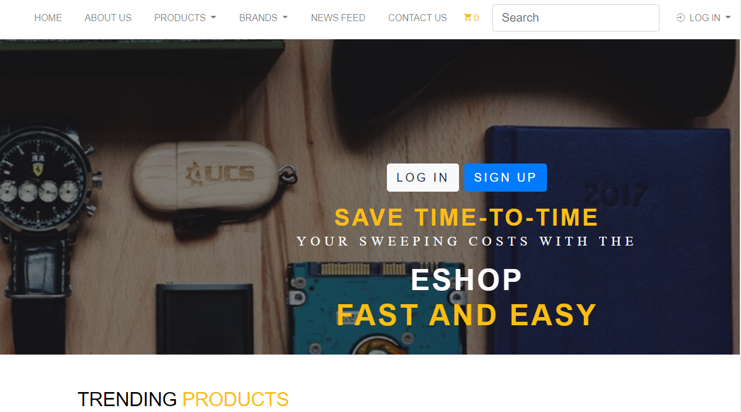

Figure 5.8: Home Page

1. **About Us**

This is the About Us section.

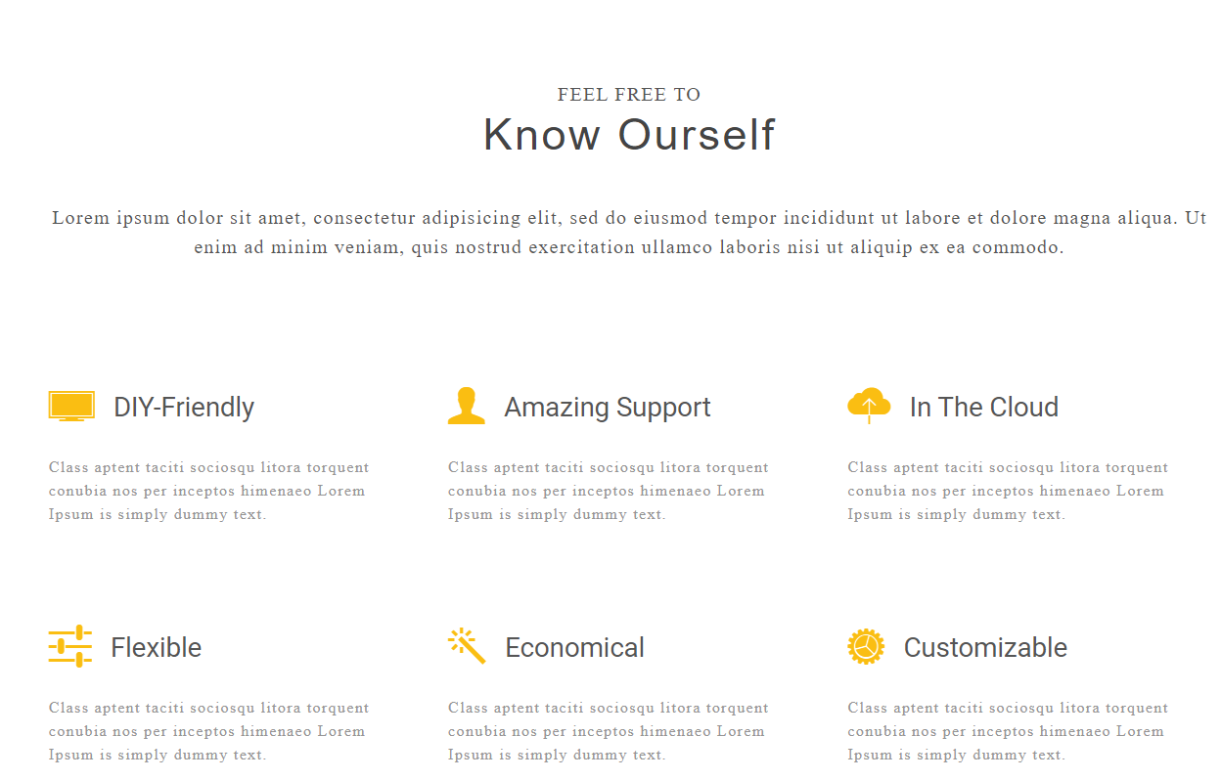

Figure 5.9: About Us

1. **Products**

User can buy products from this section.

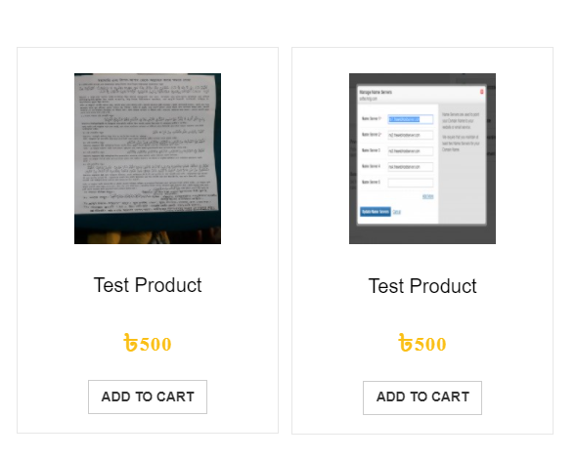

Figure 5.10: Products

1. **Brands**

This page is about Brand section.

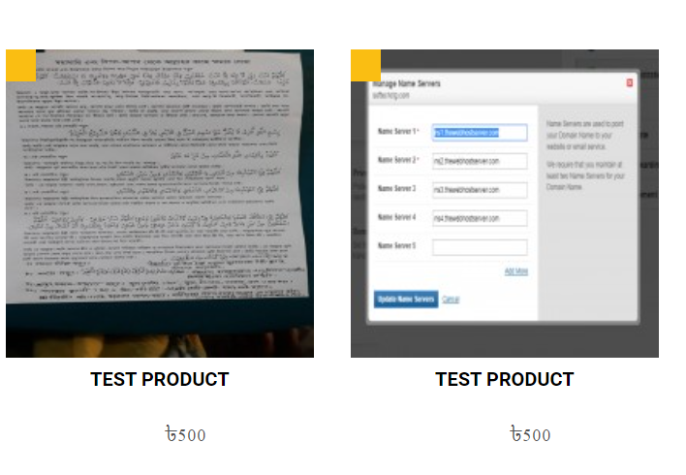

Figure 5.11: Brands

1. **News Feed**

User can also view the daily newsfeed in this section.

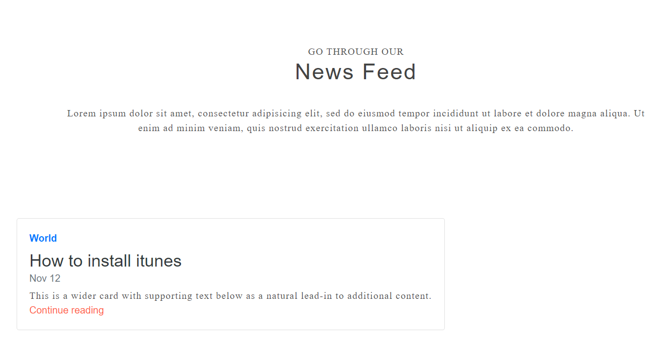

Figure 5.12: News Feed

1. **Contact Us**

This is the Contact page section.

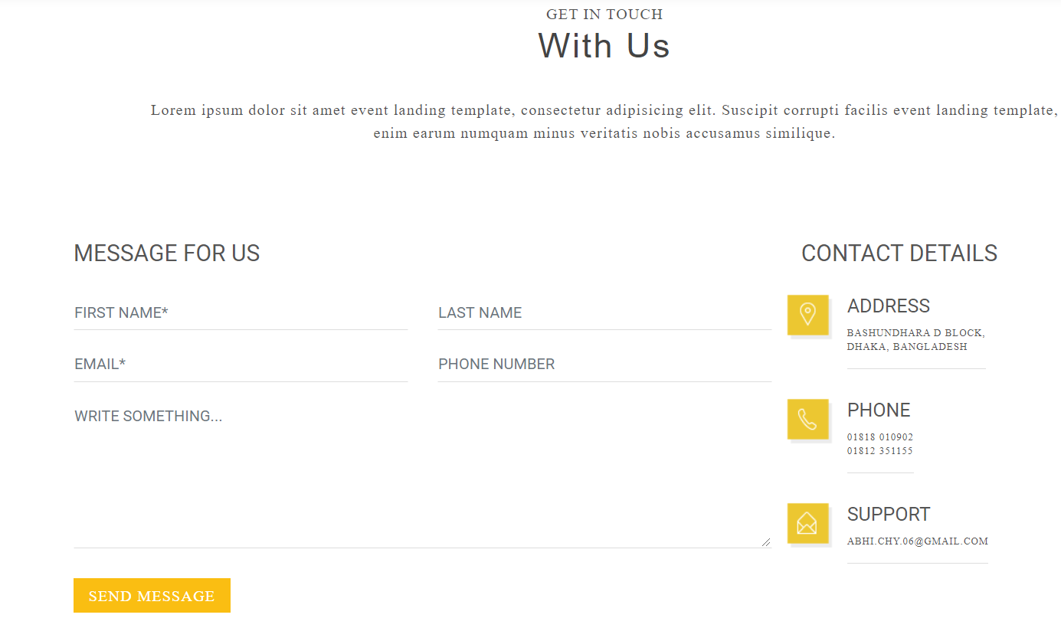

Figure 5.13: Contact Us

1. **Add To Cart**

User can view the selected products from our Add To Cart section.

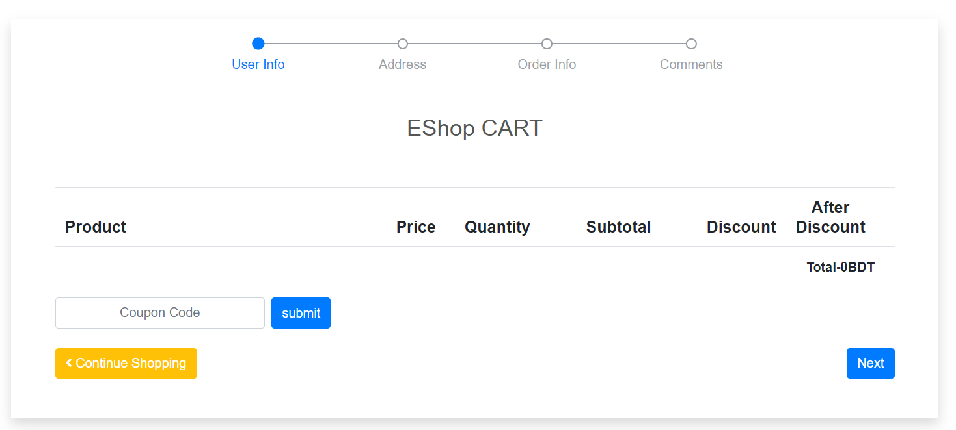

Figure 5.14: Add To Cart

1. **Register Form**

This is the registration page for user to buy their selected products.

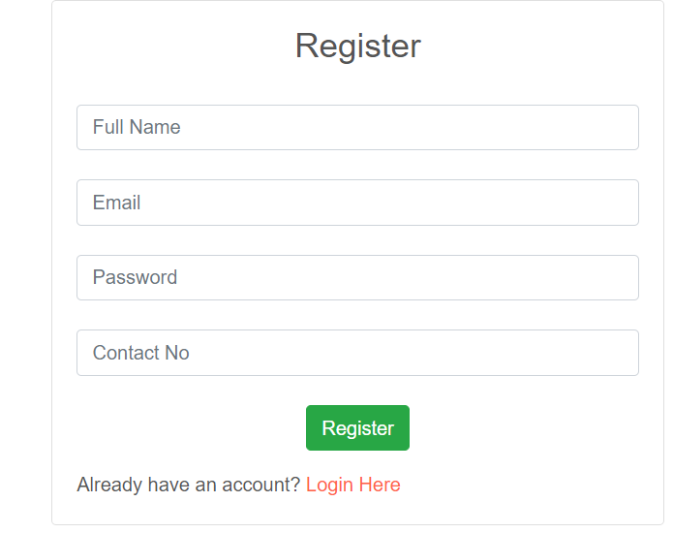

Figure 5.15: Registration Form

1. **User Login**

User can login into their account from this section.

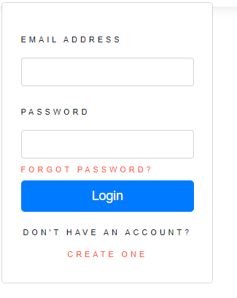

Figure 5.16: User Login

1. **Admin Dashboard**

Admin can use this section after successful login.

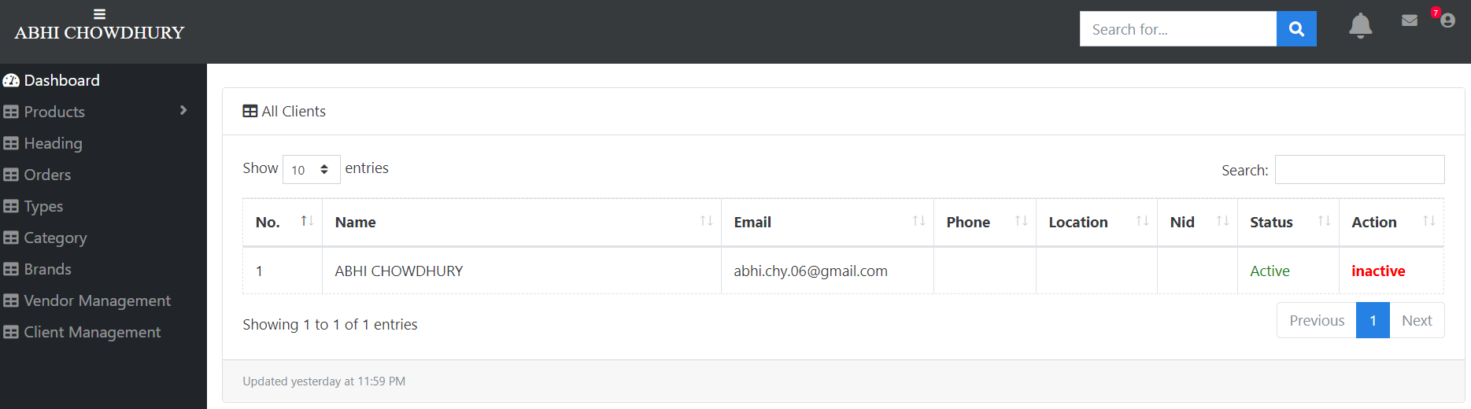

Figure 5.17: Admin Dashboard

1. **Vendor Dashboard**

After successful login vendor can use this dashboard.

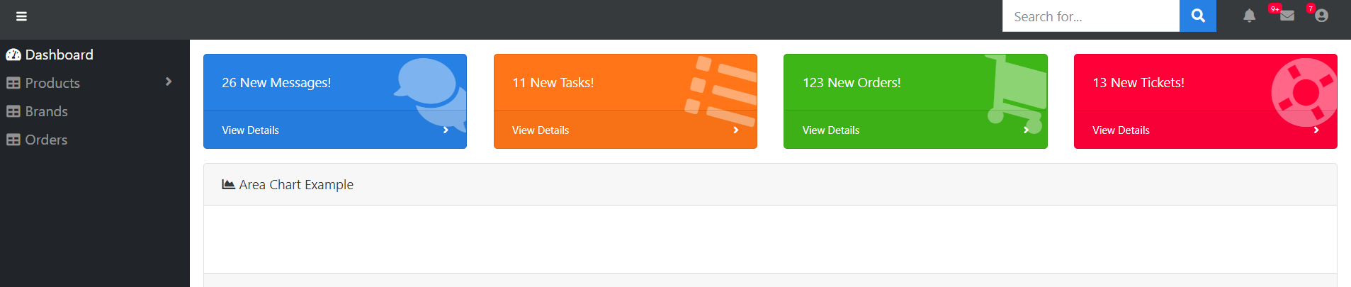

Figure 5.18: Vendor Dashboard

# Chapter 6

**Result and Test Analysis**

**6.1 Test Case**

**Items to Be Tested**: All the features in the functional requirement of our e-commerce will be tested. Some of the element has tested and some were tested accordingly to check for errors or possible bugs. Here are the functionality which has been tested.

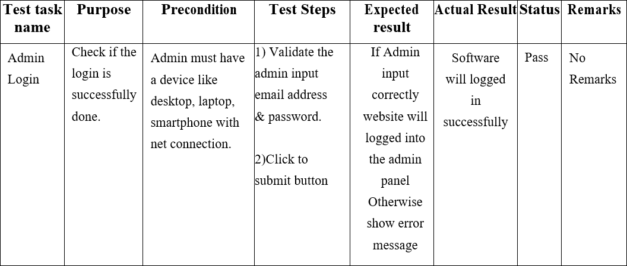

Table 6.1: Test Cases for Admin login

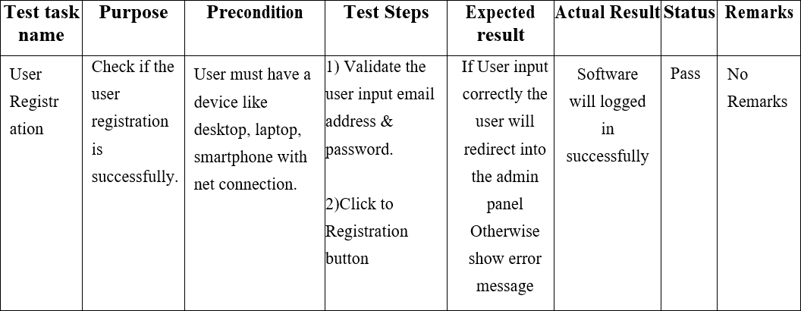

Table 6.2: Test Cases for User registration

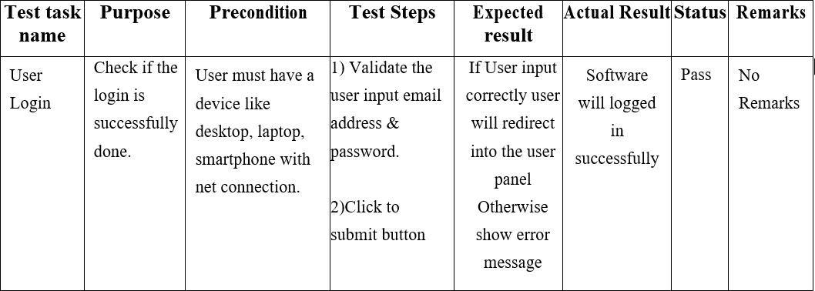

Table 6.3: Test Cases for User login

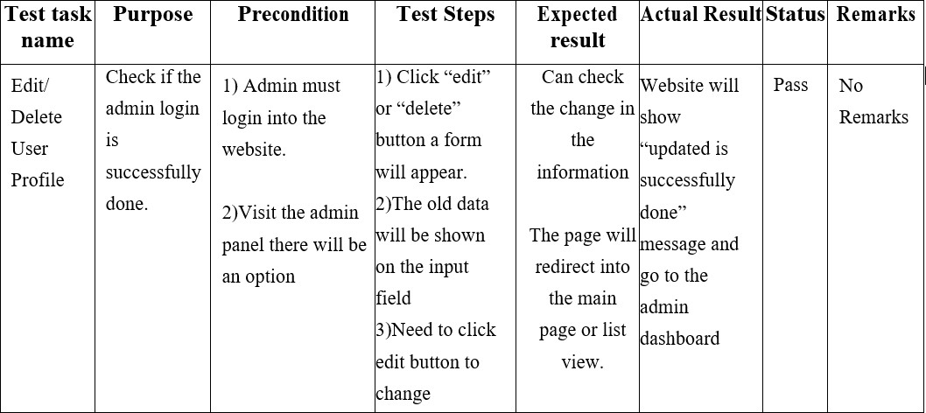

Table 6.4: Test Cases for Edit/ Delete User profile

After Successful Test Cases, we need to check the maintenance of the website.

Though Ecommerce has deployed for test purpose the website should be maintained and detect bug regularly. Always need to check site speed, image loading of the products, run through multiple screen size check, go through forms and sign-up.

Regular website backups need to be done and ensure themes and plugins are up to date. Security measurement also needs to be dealt with. The admin and login areas of website are especially vulnerable. It can be protected through the firewall and also by installing plugins that limit the number of login attempts allowed acting as a barrier for malicious endeavors.

**6.2 Results**

For justifying test cases there were few bugs found while running the software. Retrieving the data from the database, some issues came up. But most of the cases the procedure runs smoothly. There was some issue with responsiveness but after a few tests, the issue got resolved. The main task of this e-commerce is to make the site very fast and user-friendly. Fortunately, the selected tasks that were assigned runs without any flaw.

# Chapter 7

**Project as Engineering Problem Analysis**

**7.1 Sustainability of the Project**

In e-commerce, the concept of sustainability can range from business models to packaging products and its role will become increasingly important in the coming years. The use of mobile smartphones and the internet, among all classes of people, have increased drastically over the last decade. The growth suggests that the use would increase even further in the future. Starting from selecting and buying products through online everything has become more digitized in their manner. Considering such a change in the social atmosphere, it is safe to say that the E-Commerce system is highly sustainable. It works just like any other site or mobile app. It is very likely that in the near future people would be more interested to meet their everyday needs through online activities and transactions. The E-Commerce system characterizes for such a change, securing its sustainability.

**7.2 Social and Environmental Effects and Analysis**

The advent of the Internet and e-commerce has brought a new way of marketing and selling many products. The most important effect of the E-Commerce on a social level is its efficiency. Product selection and the extent to which the usage of the E-Commerce saves time instead of buying offline. On an individual level, the effect has a great positive outcome. Collaboratively, it is sensational. As more people use the E-Commerce System, it would mean that a larger portion of the population would be using a digitalized system of buying products through online in a much secure way. Large scale use of a digitalized system can be considered a development in the general social status to some extent. As COVID 19 has made traveling itself a challenge and the only cure for this disease is social distancing and staying away from home. Fortunately, this issue can be easily solved by buying selected products through online from our E-Commerce. The E-Commerce system has no effect on the environment as well. Instead of buying products offline in a hassle way sometimes by waiting in a queue, the user can easily buy their selected product from their home through online. Buying products offline going through the shop in the crowd creates an unpleasant environment. Our E-Commerce is the perfect solution of this problem. The user can simply see the products and can also decide before buying the product. This would result in a more comfortable and pleasant environment for both the user and also for us.

**7.3 Addressing Ethics and Ethical Issues**

Our E-Commerce system does not hold any ethical risk or issues. The user are required to provide some general information for shipment of their selected product which are kept highly confidential in our database. The privacy of the information is strictly maintained. Since it is an online-based e-commerce system, the E-Commerce System will be more available to those who have better access to the internet which would clearly state that the people with better internet access would have higher chances of buying their products from our system. However, the usage of phones and the internet has become common among all classes of people which suggests that the issue is quite negligible. As we know that being an ethical seller is the only way to win more and more customers and to hold them overtime to increase our service.

# Chapter 8

**Future Work and Conclusion**

**8.1 Future Works**

For the future work of our E-Commerce, the system can be made more efficient and dynamic as well. One thing that I noticed that in terms of efficiency and performance we need more developers as well as system administration people to make these e-commerce as one of the giant tech services. In this whole report and project, I tried my best to provide as much information as possible. The journey was not simple. There were many ups and downs, obstacles, new ideas and implementations that I have gained when making this dynamic e-commerce system. The need to use of effective management information systems and use of appropriate techniques is essential when working professionally. To deliver quality service top management and to mitigate the gap between the user’s expectations and the employee’s perception is important. The skills that I have gained throughout my undergraduate journey was priceless and memorable.

**8.2 Conclusion**

During my internship period I had worked on the ecommerce website as well as on a admin panel software and also now working on a new training based software. This e-commerce system was electronic version of buy and sell. In order management system, maintaining all the processes manually is very difficult and keeping all the data accurately is very hard. So, this issue can be easily maintained through our system. With the Internet connection, user can buy any product from here. This system with more user-friendly approach then before so that user can easily use it. Payment gateway can also be easily made as there are many options.

It has been a great opportunity for me to work as a software developer during internship at Cursor. This internship period was like a step stone to my carrier within the work advertise. Amid internship I learned numerous vital information throughout my journey. The internship program made a difference me to think in an advanced way of how our software companies work in our country. When doing my Internship at Cursor they instructed me on how to handle distinctive client, technology advancement. This gave me a clear thought as well as a clear idea on how to handle myself to create and build up my career as a software engineer. All in all, I especially want to thank all my teachers for their highly important advice and solutions for which I had come this much far in my overall life journey.

**References**

[1] E-Business-Roadmap for Success, by Ravi Kalakota and Marcia Robinson, Addison Wesley Publishing Company, Inc. 1999

[2] H. Degen and X. Yuan, UX Best Practices. How to Achieve More Impact with User Experience. McGraw-Hill Osborne Media, 2011.16

[3] Bagby, J. W. 2003. Cyberlaw Handbook for E-Commerce (Cyperlaw Handbook for E-Commerce). South Western Educational Publishing

[4] Boritz, J. E. and W. G. No. 2011. E-commerce and privacy: Exploring what we know and opportunities for future discovery. Journal of Information Systems (Fall): 11-45